**Integrated Test Range**

**Defense Research and Development Organization**

**Chandipur, Odisha (756025)**

**Summer Training (2019-2020)**

**Brief Report on Orientation Program**

**Name: -** Anurag Yadav

**Roll No: -** T018421

**College Name: -** Madan Mohan Malaviya University of Technology Gorakhpur, U.P. (273010)

**Application ID: -** 350

TABLE OF CONTENTS

introduction #

Section 1.1 #

Subsection 1.1.a #

Subsection 1.1.b #

Subsection 1.1.c #

Section 1.2 #

Section 1.3 #

Missile and test range #

Section 2.1 #

Section 2.2 #

Subsection 2.2.a #

Subsection 2.2.b #

Subsection 2.2.c #

Section 2.3 #

target system for test and evaluation #

Section 3.1 #

Section 3.2 #

Section 3.3 #

Subsection 3.3.a #

Subsection 3.3.b #

Subsection 3.3.c

telemetry system #

Section 2.1 #

Section 2.2 #

Subsection 2.2.a #

Subsection 2.2.b #

Subsection 2.2.c #

Section 2.3 #

Electro optics tracking system (eots) #

Section 3.1 #

Section 3.2 #

Section 3.3 #

Subsection 3.3.a #

Subsection 3.3.b #

campus area network #

Introduction #

Resource sharing #

Types of network #

Internet #

CAN #

Objective #

Services #

Used s/w and h/w #

Block diagram #

Switch #

Types #

VLAN #

What is data center? #

power system in range #

Section 3.1 #

Section 3.2 #

Section 3.3 #

Subsection 3.3.a #

Subsection 3.3.b #

mission coordination #

Section 2.1 #

Section 2.2 #

Subsection 2.2.a #

Subsection 2.2.b #

Subsection 2.2.c #

Section 2.3 #

range communication system #

Section 3.1 #

Section 3.2 #

Section 3.3 #

Subsection 3.3.a #

Subsection 3.3.b #

computer data processing #

Section 2.1 #

Section 2.2 #

Subsection 2.2.a #

Subsection 2.2.b #

Subsection 2.2.c #

Section 2.3 #

Range instrumentation radar #

Section 3.1 #

Section 3.2 #

Section 3.3 #

Subsection 3.3.a #

Subsection 3.3.b #

Subsection 3.3.c #

range and flight safety #

Section 2.1 #

Section 2.2 #

Subsection 2.2.a #

Subsection 2.2.b #

Subsection 2.2.c #

Section 2.3 #

telecommand system #

Section 3.1 #

Section 3.2 #

Section 3.3 #

Subsection 3.3.a #

Subsection 3.3.b #

Subsection 3.3.c

environmental safety #

Section 2.1 #

Section 2.2 #

Subsection 2.2.a #

Subsection 2.2.b #

Subsection 2.2.c #

Section 2.3 #

Introduction

A campus area network also known as **campus network**, **corporate area network** or **CAN** is a computer network made up of an interconnection of local area networks within a limited geographical area. The networking equipment (switches and routers) and transmission media (optical fiber, cabling) are almost entirely owned by campus owner.

A campus area network is larger than a local area network but smaller than metropolitan area network or wide area network.

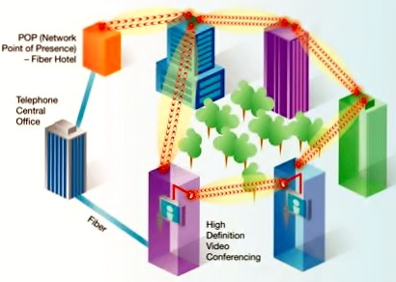

Resource Sharing

In networking, network share, is a computer resource made available from one host to other hosts on a network. Resource sharing involves sharing piece of information on a computer that can be remotely accessed from other computers either via local area network or intranet. Network sharing is made possible by inter-process communication over the network.

Examples- shared file, shared printer, shared scanner etc.

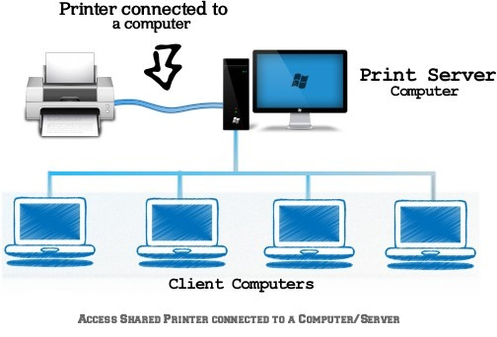

Types of network

1. LAN

A local area network is a computer network that interconnects computers within a limited area such as residence, school, laboratory, university campus or office building. Its range up to 10 kilometers.

1. 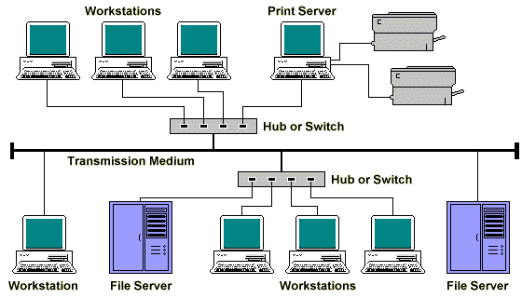
2. MAN

A metropolitan area network interconnects hosts with computer resources in geographic region of the size of a metropolitan area.

The term MAN is applied to the interconnection of LANs in a city into single larger network which may turn also offer efficient connection to wide area network. Its range up to 50 km.

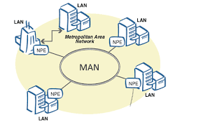

1. WAN

A wide area network is telecommunications network that extends over a large geographical distance for the primary purpose of computer networking. Wide area network is often established with leased telecommunication circuits. Its range is unlimited.

